**Abstract**

This comprehensive report examines Spotify's strategic utilization of digital marketing to reinforce its position as a leader in the music streaming industry. Initially, it explores the evolution of Spotify since its inception in 2006, highlighting its freemium model and the strategies employed to convert free users to premium subscribers. The main body of the report includes discussion on Spotify's online ecosystem and strategic digital engagements, highlighting the company's extensive digital reach. This section outlines how Spotify leverages social media to enhance its brand visibility and interact with users. Following that, the report examines the purposes behind Spotify's digital presence, which were identified as information dissemination, nurturing customer relationships, and facilitating e-commerce transactions. Subsequently, the report then delves into Spotify’s customer dynamics through discussions strategies undertaken by the company to understanding its customers’ behaviors, the overarching customer paradigm, their buying decisions, and its target customers. It showcases how Spotify's data-driven approach, integrating machine learning and cultural insights, have effectively catered to individual preferences and influenced subscription choices, essentially underlining the company's strategic efforts to understand and engage its diverse user base. Following that, the digital marketing funnel, from awareness to retention, is explored in detail, highlighting Spotify's targeted strategies at each stage to optimize conversions and ensure long-term user engagement. Lastly, the report evaluates the economic impact of Spotify's social media marketing efforts, illustrating how these initiatives have significantly contributed to the platform's exponential growth, particularly in economic terms.

**Table of Contents**

1.0 Introduction to Spotify’s Evolution and Digital Marketing Landscape 4

2.0 Spotify's Online Ecosystem and its Strategic Digital Engagements 5

2.1 Exploring Spotify's Digital Presence 5

2.2 Purpose of Spotify’s Digital Presence 7

3.0 Analysing Spotify’s Strategic Insights into Customer Dynamics 9

3.1 Understanding Spotify’s Customer Behaviours 9

3.2 Understanding Spotify’s Customer Paradigm 10

3.3 Understanding the Buying Decisions of Spotify’s Customers 11

3.4 Understanding the Target Customers of Spotify 12

4.0 Navigating Spotify's Digital Marketing Funnel: From Awareness to Retention 13

4.1 Spotify’s Strategies at the Awareness Stage 13

4.2 Spotify’s Strategies at the Interest Stage 16

4.3 Spotify’s Strategies at the Consideration Stage 18

4.4 Spotify’s Strategies at the Conversion Stage 20

4.5 Spotify’s Strategies at the Retention Stage 22

5.0 Leveraging Digital Dynamics: Spotify's Social Media Integration and Economic Growth 23

5.1 Spotify's Presence on Social Media and Its Strategies for Marketing on These Platforms 23

5.2 Economic Significance of Spotify’s Digital Community Engagement Efforts 24

Reference List 25

**Table of Figures**

Figure 1: An Example Illustrating Spotify's Wrapped Campaign (Lim, 2023) 6

Figure 2: Organic Search Result of Spotify (Leatherland, 2023) 14

Figure 3: Spotify's Partnership with Chris Bumstead (Geyser, 2024) 14

Figure 4: Shareability of Spotify's Wrapped Campaign on Multiple Social Media Platforms (Lim, 2023) 15

Figure 5: Spotify's Alternative Sign-Up Options (Spotify, n.d.-b) 17

Figure 6: Spotify's "Taste Onboarding" (Leanplum, 2018) 17

Figure 7: Clear Distinction between Spotify’s Free and Premium Offerings (Spotify, n.d.-c) 18

Figure 8: Different Premium Plans Offered by Spotify (Spotify, n.d.-c) 19

Figure 9: Clear Call-to-Action for Customers to Select from the Different Premium Plans (Spotify, n.d.-c) 20

Figure 10: Clear Call-to-Action for Customers to Finish the Final Process of Conversion 21

Figure 11: Welcome Email from Spotify's Team (Mackeviciute, 2023) 22

# 1.0 Introduction to Spotify’s Evolution and Digital Marketing Landscape

Daniel Ek and Martin Lorentzon established Spotify in 2006, and since then, the company has emerged as a significant player in the music streaming industry, offering global access to a vast selection of music and podcasts. It offers worldwide access to music and podcasts through both its apps and a detailed website. The platform operates on a freemium model, providing a no-cost, ad-supported option alongside a premium subscription that offers benefits such as no ads, offline listening, and better sound quality. As of this report's writing, Spotify boasts over 602 million active users in 180 markets, with 236 million being paid subscribers, showcasing its broad appeal and success (Spotify, n.d.-a). The company's strategy focuses on converting free users to paid subscribers, thus building its revenue base. Financially, Spotify balances its revenue and costs. The main income comes from premium subscriptions, complemented by ads targeting free users. These ads aim to engage those not paying, while the company also faces significant expenses. Royalties to artists and content providers, based on streaming numbers, make up a large part of these costs. This payment model ensures a wide range of music and podcasts. Spotify also invests in tech improvements and marketing to boost engagement and grow its market presence, essential for maintaining its industry lead.

This report will exclusively focus on Spotify's website to dissect its digital marketing strategies, starting with an analysis of the site's role in Spotify's overall online presence and its strategic use for business growth, including information dissemination and customer engagement. It will then explore how Spotify understands and influences customer behaviour through website analytics, feedback, and online research, providing insights into user preferences and decision-making processes. The examination extends to the digital marketing funnel, detailing strategies across stages from awareness to purchase intention, highlighting the website's contribution to nurturing user journeys. Finally, the report will evaluate the economic impact of integrating Spotify's social media efforts with its website, showcasing how this synergy enhances brand visibility and drives revenue. This focused approach aims to offer a comprehensive view of Spotify's digital marketing efficacy through its website.

# 2.0 Spotify's Online Ecosystem and its Strategic Digital Engagements

## 2.1 Exploring Spotify's Digital Presence

In the digital era, where online presence translates to brand strength, Spotify's February 2024 statistics reveal its expansive digital reach. The platform takes pride in a vibrant social media footprint, with 23 million likes and followers on Facebook (Facebook, n.d.), a dynamic community of 2.6 million followers on TikTok (TikTok, n.d.,), and an impressive following of 14.3 million on X, marking its digital existence since November 2008 (Twitter, n.d.,). Besides that, the introduction of Spotify's Wrapped in 2016 heralded a new cultural milestone, turning yearly user listening summaries into a viral sensation (Chan, 2023) (*Figure 1*). Note that a more in-depth discussion on Spotify’s Wrapped campaign will be provided in the subsequent sections of this report. On X alone, the 2022 Wrapped campaign spurred a 15% increase in related posts within a mere three days of its release, according to SproutSocial, rising to an astounding 400 million mentions. This surge built on the previous year's momentum, which saw a 461% jump in posts (Murray, 2023). These impressive numbers from a single platform are just the tip of the iceberg, suggesting a monumental, combined impact across all social media outlets. Further solidifying its digital dominance, Spotify's website attracted nearly half a billion visits in January 2024 (Similarweb, n.d.). Moreover, the app's 238 million downloads in 2022 have cemented its status among the top 10 mobile apps worldwide, indicative of its sustained popularity and digital relevance in a competitive landscape (Ceci, 2024). Given the above evidence, the myriad touchpoints across social platforms and the overwhelming user interactions exemplify Spotify's strategic prowess in sculpting a commanding online presence, ultimately fortifying its position at the vanguard of digital music and culture.

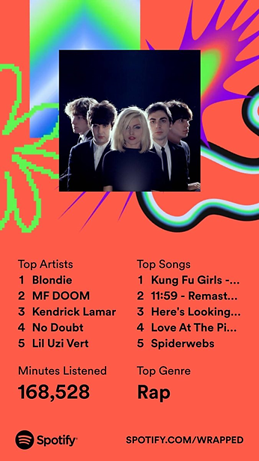

Figure 1: An Example Illustrating Spotify's Wrapped Campaign (Lim, 2023)

## 2.2 Purpose of Spotify’s Digital Presence

Spotify's strategic deployment of its online presence is meticulously designed to serve multiple objectives, central to which are information dissemination, nurturing customer relationships, facilitating e-commerce, and fostering collaboration with a wide array of stakeholders.

Spotify excels in engaging its audience by effectively using its digital platforms to communicate updates, new music releases, podcasts, and curated playlists. The platform's annual Wrapped campaign is a standout example of this strategy, transforming users' listening data into engaging, shareable visuals that significantly boost engagement and encourage sharing across social networks (Spotify, 2022). In the year 2021, Spotify revealed that their Wrapped feature was accessed by 120 million individuals, marking a significant rise from the 30 million users in 2017 and underscoring the growing allure and impact of the campaign in engaging users. Additionally, the sharing of Wrapped graphics by 60 million users on various social platforms underscores the success of the effort in promoting extensive engagement and illustrates Spotify's effectiveness in amplifying its brand presence and user interactions digitally (Murray, 2023). Beyond Wrapped, Spotify actively engages with its audience on social media platforms like Instagram and Twitter, conducting polls, promoting user-generated content, and leading hashtag-driven campaigns. These efforts strengthen Spotify's user relationships and underscore its commitment to ongoing engagement. This comprehensive strategy not only cements Spotify's position as a leading music streaming service but also showcases its dedication to fostering continuous engagement with its user base. Through these initiatives, Spotify not only retains loyalty among its existing users but also expands its audience, supporting its growth and solidifying its role as a pioneer in the digital music industry.

Spotify's engagement with its user base through online platforms exemplifies a commitment to fostering strong customer relationships. The Spotify Community forum and social media channels act as vital links for user support and feedback, establishing a direct communication pathway that allows the company to quickly address user concerns and incorporate their insights into future enhancements (Leslief, 2022). A standout example of Spotify's user-driven innovation is the introduction of the AI-powered "DJ" feature, which personalizes the listening experience by curating music and providing commentary tailored to individual tastes, based on user feedback and listening habits (Spotify, 2023). This feature, built on Spotify's existing strengths in playlist personalization like Discover Weekly and the annual Wrapped campaign, demonstrates how Spotify leverages listening trends and preferences to create highly resonant playlists for each user. Such personalization deepens user satisfaction and loyalty, as it reflects a service that values and understands its audience's unique musical tastes. Moreover, Spotify's regular updates and the introduction of new features, such as the AI DJ, are directly influenced by user feedback and usage patterns, showcasing Spotify's proactive stance in evolving with its community's needs. This approach not only maintains but also enhances the connection with its audience, ensuring Spotify remains a preferred choice for music streaming by continually enriching user experience and fostering a loyal, satisfied user base (Spotify, 2023).

Spotify's digital presence is intricately designed to facilitate e-commerce transactions, with the primary aim of converting free users into paid subscribers. This is achieved through a user-friendly sign-up process and a transparent presentation of the benefits associated with premium subscriptions. Such a streamlined approach is vital for Spotify's revenue generation, as subscription sales constitute the main source of its income. By making the upgrade from free to premium seamless and intuitive, Spotify effectively harnesses its online platforms to stimulate e-commerce activities. The impact of this strategy on Spotify's financial health is significant, as evidenced by the exponential growth of its premium subscriber base over the years. Starting from just over 20 million paying subscribers in 2015, the numbers surged to 83 million by mid-2018, reaching 195 million by September 2023 (Götting, 2024). This remarkable increase is a direct result of Spotify's focused online efforts to simplify e-commerce transactions, making it easy for users to see the value in and opt for a premium subscription. Spotify's digital interfaces prominently feature the benefits of uninterrupted listening, superior audio quality, and the ability to play music offline, from their main site to their social media presence, making certain that users are fully aware of the perks that come with a premium subscription. This not only improves the user experience but also significantly boosts Spotify's subscription sales, showcasing the critical role of a well-orchestrated online presence in facilitating successful e-commerce transactions within Spotify's business model.

# 3.0 Analysing Spotify’s Strategic Insights into Customer Dynamics

## 3.1 Understanding Spotify’s Customer Behaviours

Spotify's approach to understanding its customers’ behaviour is fundamentally driven by an intricate analysis of data, encompassing user playlists, listening history, and interactions with the platform's interface. By meticulously analysing each user's listening habits, Spotify creates a distinct experience for its 602 million users (at the time of the writing of this report), effectively turning the platform into 381 million unique versions of itself (Spotify, n.d.-a). This personalization extends from crafting individualized playlists to offering song recommendations that resonate with each user's specific tastes. Highlighted by Spotify’s VP of Personalization, Oskar Stål, during his 2021 TransformX talk, the core of Spotify's strategy involves feeding a diverse array of user information into machine learning (ML) models (Spotify Engineering, 2021). According to Oskar, the accumulation of nearly half a trillion of data enables these models to forge sophisticated associations between artists, songs, podcasts, and playlists, enhancing their predictive accuracy. Yet, Spotify's ML models extend their capabilities far beyond basic data analysis, venturing into the realm of contextual understanding. At Spotify, machine learning models are programmed to meticulously assess factors such as the time of day, the intended use of a playlist (whether for working out or unwinding), and the user's choice of device (mobile or desktop). This level of contextual insight enables Spotify to refine its recommendations with exceptional accuracy, ensuring they align closely with the unique preferences and needs of its extensive user base. Through the strategic deployment of these sophisticated ML models throughout its ecosystem, Spotify is able to offer highly personalized recommendations that deeply connect with each user. Consequently, Spotify not only elevates the standard for personalized digital experiences but also strengthens its position as a leader in customer engagement, leveraging technology to create a more intimate and satisfying listening experience.

## 3.2 Understanding Spotify’s Customer Paradigm

Spotify's efforts to understand its customer paradigm are characterized by a comprehensive approach that transcends mere analysis of individual user behaviour, embracing a broader perspective that acknowledges the impact of cultural and social dynamics on music consumption. This approach is evident in the company's initiatives like global music trend reports and genre-specific insights, which shed light on the evolving musical landscape and inform Spotify's content curation, ensuring it aligns with the collective mood and cultural moments. Such strategies enable Spotify to forge a deeper connection with its audience by personalizing the listening experience in a way that resonates on a communal level. The integration of these cultural insights with detailed behaviour analysis results in a nuanced understanding of its customer paradigm, allowing Spotify to not only respond to but also anticipate and influence musical tastes and trends. A prime example of this strategy in action is Spotify's annual Wrapped campaign, which in 2023 engaged over 225 million Monthly Active Users and saw a 40% increase in user engagement year-over-year across 170 markets (Spotify, 2024,). This campaign serves as a pivotal research tool, enabling Spotify to capture and analyse global listening trends, further enhancing its comprehensive grasp of the musical landscape and reinforcing its position as a key player in the music ecosystem.

## 3.3 Understanding the Buying Decisions of Spotify’s Customers

Spotify's nuanced strategy in navigating customer buying decisions, particularly through its "freemium" model, underscores its adeptness in market segmentation and conversion. This model, delineating a choice between an ad-supported free tier and an ad-free premium subscription, is pivotal for engaging users and facilitating their transition to paid services. While Spotify keeps the finer details of its strategic manoeuvres under wraps, industry observations and Spotify's public disclosures shed light on its methodologies. The success of Spotify's freemium strategy in transitioning users from its free service to paid subscriptions is highlighted by its significant contribution to the company's expansion story. This approach not only garners insights into user preferences and ad tolerance but also refines Spotify's promotional tactics to boost premium subscription rates (Goff, 2017). The implementation of this model has significantly contributed to Spotify's subscriber expansion, evidenced by the remarkable 42.86% conversion rates from free users to premium users in 2017 (Goff, 2017), stark contrast to the typical 2 to 5 percent conversion rates seen by most companies, as noted by Harvard Business Review (Kumar, 2014).

Furthermore, Spotify's continuous experimentation with its pricing model and the introduction of features exclusive to the premium subscription underscore its commitment to refining its understanding of customer buying decisions, ensuring that the service remains appealing and relevant to a diverse audience (Slattery, 2018). This strategic approach not only enhances user satisfaction but also drives the platform's growth by converting free users into loyal, paying subscribers. A strategic decrease in the average revenue per user (ARPU) for Spotify's premium segment, marked by a reduction from €6.84 in 2015 to €5.32 in 2017, can be seen as a calculated move to boost overall subscriber numbers, facilitated by offerings such as family packages and student discounts. This adjustment in ARPU reflects Spotify's strategic pricing adjustments to increase its premium subscriber base while maintaining a competitive edge in the market. By the end of 2017, Spotify saw its premium subscribers swell to 71 million, a 46 percent increase year-on-year, bringing the proportion of premium users to nearly 45 percent of its total user base—a notable jump from the historical norm of about 25 percent. This shift not only demonstrates Spotify's ability to effectively convert free users into paying subscribers but also underscores the economic value of its subscription model, with the premium tier accounting for 90 percent of its revenues. Such success highlights Spotify's skill in leveraging its understanding of customer preferences and buying behaviours to drive growth and sustain its market leadership.

## 3.4 Understanding the Target Customers of Spotify

While there is no explicit or official statement detailing Spotify's strategy for understanding its target customers, the comprehensive analysis of its methods—encompassing individual customer behaviour, the overarching customer paradigm, and buying decisions, suggests a sophisticated and integrated approach of the company in understanding its target customers. Drawing from all three discussions above which were substantiated with either industry observations or Spotify's public disclosures, it is thereby evident that the company's strategy in understanding its target customers involves the leveraging of advanced machine learning to dissect and interpret listening habits and preferences, which is further enriched by user feedback on features like "Discover Weekly" and "Wrapped." At the same time, engagement with social media and cultural trends, further broadens Spotify's understanding of diverse consumer preferences. The freemium model is crucial too where its role was to draw a wide user base that supplies valuable data for honing marketing strategies and boosting conversion rates. Working in conjunction, Spotify's strategic pricing and exclusive premium features plays the role of demonstrating an acute awareness of customer buying patterns, where user satisfaction are enhanced, and platform growth is being fostered. In essence, this holistic strategy of Spotify not only caters to the distinctive needs and preferences of its target customers but at the same time, solidifies the company's market dominance by skilfully translating its in-depth understanding of its target customers into substantial economic value.

# 4.0 Navigating Spotify's Digital Marketing Funnel: From Awareness to Retention

The digital marketing strategy utilized by Spotify orchestrates a deliberate path that guides potential listeners from their first encounter with the brand to becoming devoted subscribers. Starting with the Awareness level, the aim is to make Spotify known to a broad audience through diverse advertising channels. In the Interest stage, efforts focus on capturing the curiosity of the audience by showcasing Spotify's unique features and extensive music library. As individuals move into the Consideration phase, they assess the advantages of Spotify, including the premium benefits, against other available options. The Conversion phase is pivotal, focusing primarily on encouraging actions that lead to the conversion from free usage to signing up for a Premium subscription or the immediate signing up for a Premium subscription should the user not have signed up for a free account initially. The journey concludes with the Retention stage, where Spotify implements strategies to keep subscribers engaged and satisfied, making the service an indispensable part of their daily lives, and ensuring their long-term commitment. This funnel represents a holistic marketing approach, aiming not only to attract new users but also to maintain their engagement and loyalty, thus driving Spotify's ongoing success in the dynamic world of digital music streaming.

## 4.1 Spotify’s Strategies at the Awareness Stage

During the initial awareness phase, Spotify implements a diverse array of tactics including optimizing for search engines, leveraging influencers, utilizing social media with carefully chosen hashtags, partnering with other brands, and engaging in both content and viral marketing activities such as the Wrapped Campaign, all aimed at enhancing its profile and drawing in new users. Superior SEO ensures Spotify's high visibility on Google for keywords or search terms related to music streaming (*Figure 2*) (Leatherland, 2023). Influencer marketing, which is partnerships like those with YouTube sensation Emma Chamberlain (Grabnfts, 2023) and the five-time Mr. Olympia - Christopher Bumstead, for Gymshark (Geyser, 2024), leverages the vast followings of these influencers to introduce Spotify's offerings to a wider audience (*Figure 3*). Social media marketing was employed by Spotify through the introduction of engaging campaigns such as #thatsongwhen and #SpotifyWrapped, which served to motivate users to share their music experiences, significantly extending Spotify's reach (Karthikeyan & Kumar, 2023). Additionally, collaborations with over 76 companies worldwide, as of 2022, including Starbucks, and global telecommunication providers like Bouygues Telecom (French mobile service provider) and Vodafonewere (Australia’s largest mobile network) (Spotify, 2019) in 2019 to name a few, were also aimed at expanding Spotify's digital footprint. The Wrapped campaign, exemplifying content, and viral marketing, utilizes personalized, shareable content to engage users and encourage sharing on platforms like Instagram, Snapchat, and Facebook to name a few, essentially enhancing user engagement and brand awareness (*Figure 4*).

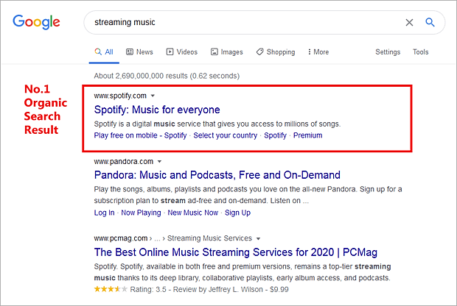

Figure 2: Organic Search Result of Spotify (Leatherland, 2023)

Figure 3: Spotify's Partnership with Chris Bumstead (Geyser, 2024)

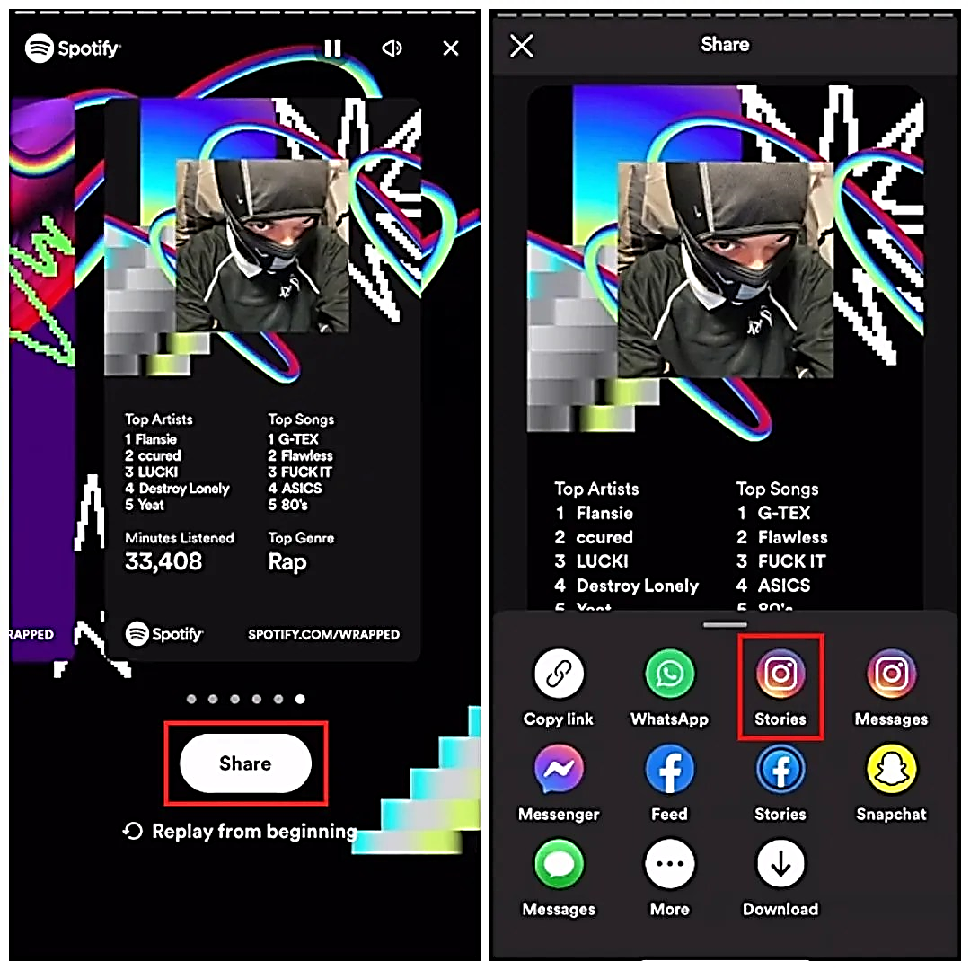

Figure 4: Shareability of Spotify's Wrapped Campaign on Multiple Social Media Platforms (Lim, 2023)

## 4.2 Spotify’s Strategies at the Interest Stage

Before exploring the strategies Spotify employs during the interest stage of its digital marketing funnel, it's essential to understand that this phase targets two main goals - firstly, to encourage new users to register for a free account, and secondly, to keep these users engaged and interested once they have joined. Successfully meeting these objectives primes users for the subsequent phases of the funnel, setting the stage for deeper engagement and continued loyalty. With these objectives in focus, the discussion now shifts to the specific strategies Spotify implements at the interest stage.

At the interest stage of its digital marketing funnel, Spotify employs a multifaceted approach to onboard new users and keep them engaged. The platform streamlines the sign-up process to be intuitive and user-friendly, effectively lowering the hurdles for new users. Enhancing this simplicity, Spotify integrates a feature for social media sign-ons, allowing users to easily register using their existing Facebook or Google accounts, a method that simplifies the process further and is likely to boost sign-up rates (*Figure 5*) (Vallala, 2023). Following registration, Spotify engages users with its "taste onboarding" process (*Figure 6*), prompting them to select their preferred artists to immediately start receiving personalized music recommendations (Leanplum, 2018). This tailored engagement is key to immersing users in the Spotify experience from the beginning. To sustain user interest, Spotify customizes each user's homepage with recommendations based on their listening habits and preferences, utilizing advanced personalization and data analytics as was pointed out in the above sections (Radarr, n.d.). At the same time, Spotify introduces "Blend", a unique feature that allows users to create a collaborative playlist with friends, merging their musical tastes into a single, shared experience (Pandey, 2023). This approach not only tailors the listening experience to individual tastes but also fosters social connectivity and content sharing, thereby boosting user interaction. In addition, features such as "Blend" and the yearly "Spotify Wrapped" event, as mentioned earlier, serve to further encourage social sharing, thus creating a self-propelling cycle that is advantageous for the brand. These concerted strategies ensure that users stay engaged and interested, paving their path through Spotify's marketing funnel towards deeper involvement and loyalty.

Figure 5: Spotify's Alternative Sign-Up Options (Spotify, n.d.-b)

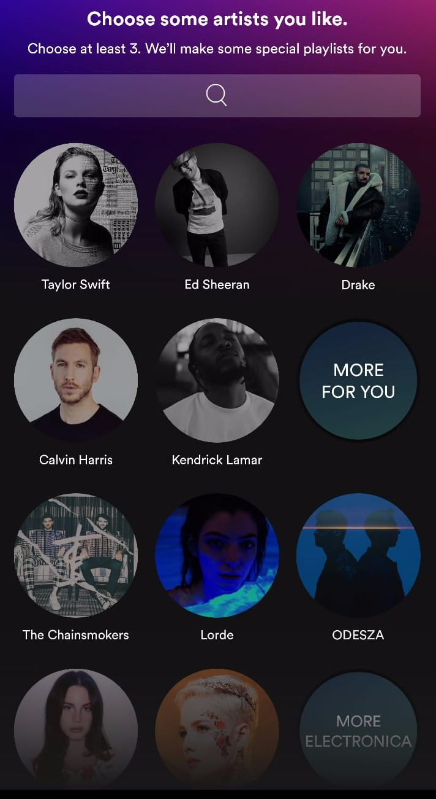

Figure 6: Spotify's "Taste Onboarding" (Leanplum, 2018)

## 4.3 Spotify’s Strategies at the Consideration Stage

In the consideration stage, Spotify deftly utilizes its freemium model along with free Premium trials to entice users with a glimpse of the superior features available upon subscription. This approach affords users the chance to savour Premium benefits without a binding commitment (Aswad, 2019,). The freemium model offers basic access with certain limitations, like shuffle-only playback, which contrasts with the premium trials that unlock a full array of features (Spotify, n.d.-c). Such trials offer a temporary, cost-free glimpse into the enhanced user experience that comes with a subscription, including ad-free listening, offline playback, and superior audio quality. As could be seen in *Figure 7*, the distinction between the free and Premium offerings is clearly outlined on Spotify's website, where users can easily compare the different packages available, including Individual, Duo, Family, and Student plans, each designed to cater to the varying needs of its diverse user base (*Figure 8*). In providing transparent information on the features and benefits of each plan, Spotify aims to empower users to make informed decisions, essentially nudging them towards considering a Premium subscription after experiencing the superior service quality during the trial period.

Figure 7: Clear Distinction between Spotify’s Free and Premium Offerings (Spotify, n.d.-c)

Figure 8: Different Premium Plans Offered by Spotify (Spotify, n.d.-c)

## 4.4 Spotify’s Strategies at the Conversion Stage

Spotify's email marketing is a pivotal element in its conversion strategy, using a series of well-crafted, targeted emails to guide free users towards premium subscriptions. After signing up, users receive personalized emails that not only showcase the value of the premium service, such as three months free, but also emphasize the limitations of the free service that can be overcome by upgrading. These emails are designed to be visually appealing and easy to digest, presenting offers in a straightforward manner, and Spotify strategically times follow-up emails to remind users when an offer is nearing its end, creating a sense of urgency. This careful balance of providing additional value without overwhelming the user is crucial to Spotify's high conversion rates from free to paid services​​. At the same time, the platform's minimalist web design, with clear calls to action, simplifies the upgrade process, enhancing user experience and nudging free users towards premium subscription (*Figure 9* and *Figure 10*).

Figure 9: Clear Call-to-Action for Customers to Select from the Different Premium Plans (Spotify, n.d.-c)

Figure 10: Clear Call-to-Action for Customers to Finish the Final Process of Conversion

## 4.5 Spotify’s Strategies at the Retention Stage

Spotify's retention strategy hinges on a robust onboarding process and strong ongoing support, vital in fostering user loyalty. New Premium users receive detailed emails that not only showcase the benefits they're signing up for but also ensure they feel welcomed and informed from the outset (*Figure 11*) (Mackeviciute, 2023). This is underpinned by a comprehensive support system encompassing a help site for self-service, a community forum fostering peer assistance, and a direct contact line for in-depth support needs (Spotify, n.d.-d). The @SpotifyCares Twitter account exemplifies the brand's dedication to immediate, social-friendly assistance, addressing issues in real-time and maintaining user satisfaction. Personalization is another key retention driver for Spotify (Anderson, n.d.). The platform's AI algorithms analyse user behaviour to provide tailor-made "Daily Mix" and "Discover Weekly" playlists, ensuring that each user's experience is as relevant and engaging as possible. The annual Spotify Wrapped feature then capitalizes on this data, creating shareable retrospectives of users' listening habits that not only celebrate individual music journeys but also encourage social sharing—turning users into brand ambassadors. Coupled with user-centric policies like audiobook refunds (Spotify, n.d.-d), Spotify's strategy skilfully blends support with personalization, making the service an integral part of users' lives and solidifying long-term commitment.

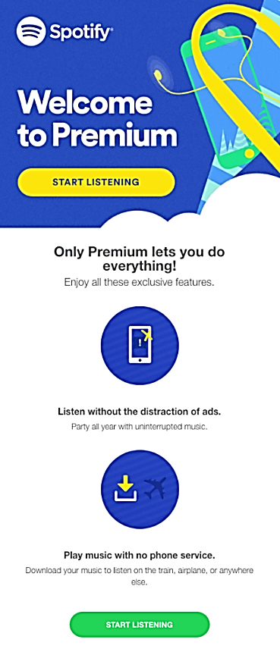

Figure 11: Welcome Email from Spotify's Team (Mackeviciute, 2023)

# 5.0 Leveraging Digital Dynamics: Spotify's Social Media Integration and Economic Growth

## 5.1 Spotify's Presence on Social Media and Its Strategies for Marketing on These Platforms

It should be noted that the social media appearances of Spotify were previously discussed in *Section 2.1*. Therefore, to avoid redundancy and repetition, this section will directly delve into the social media marketing strategies employed by Spotify. Spotify's social media footprint is vast, utilizing a variety of campaigns and features to engage audiences across numerous platforms, showcasing music as a cross-platform experience. The platform's flagship Spotify Wrapped campaign, which allows users to share their year-in-music summary, has become an annual viral sensation (Murray, 2023). As was mentioned in previous sections, Spotify further boosts user engagement with curated playlists for different moods and activities, collaborative playlists, and the “Blend” feature, facilitating social interaction, and content sharing on networks like Instagram, Twitter, Facebook, and Snapchat to name a few. Exclusive content and partnerships with artists for special releases and behind-the-scenes content also enhance Spotify's visibility on these platforms (Haran, 2023,). The emphasis on podcasts, through exclusive deals with notable creators, broadens Spotify's social reach as users share and discuss content. In essence, the direct sharing capabilities within Spotify’s platform simplify the process of sharing music and podcast favourites, underlining the platform's commitment to a unified music experience. This strategy not only boosts engagement but also cultivates a community of listeners who discover and share content, once again expanding Spotify's visibility and impact in the digital music scene.

Besides that, Spotify's social media strategy is said to have transcend traditional marketing, evolving its platform to incorporate behaviours and functionalities that were once exclusive to social media (Li, 2023). This evolution positions Spotify not just as a music streaming service but as a comprehensive digital space for eCommerce, music news, and information search, akin to platforms like TikTok or Instagram. A notable milestone in this evolution is Spotify's recent partnership with Shopify, allowing artists to sell merchandise and concert tickets directly through the Spotify app. This "retail-ification" benefits artists by providing a direct channel to promote and sell their work within the app, enhancing user engagement and potentially increasing the time spent on the platform. Moreover, Spotify's integration of merchandise sales into its annual Wrapped campaign underscores this strategic shift. In 2022, following the launch of Wrapped, Spotify experienced its most profitable week in merchandise sales ever recorded, with earnings during that period increasing by 175% in comparison to the total revenue generated during the same event the year before (Dredge, 2022). This initiative not only serves as a new revenue stream for artists but also reinforces the value of Spotify beyond music streaming royalties. As Spotify continues to blend social media dynamics into its platform, it is creating a self-sustaining ecosystem that reduces reliance on external social media platforms for promotion and engagement. This innovative approach, blending content consumption with social and commercial functionalities, marks Spotify's transition towards becoming a multifaceted digital platform that caters to the evolving needs of both artists and listeners.

## 5.2 Economic Significance of Spotify’s Digital Community Engagement Efforts

Assessing through the lens of economic impact, the integration of social media marketing has been a cornerstone in Spotify's dramatic expansion. This is reflected by the significant climb in the number of premium subscribers, escalating from 15 million in early 2015 to in excess of 220 million by the latter part of 2023 (Götting, 2024). This growth trajectory is mirrored in the monthly active users, which skyrocketed from 68 million to well over 500 million in the same period. Revenue-wise, Spotify has seen a monumental rise from 746 million euros in 2013 to almost 12 billion euros in 2022. A substantial portion of this revenue has consistently been generated from premium subscriptions, highlighting the effectiveness of Spotify's marketing funnel in converting and retaining paying customers. In essence, social media's role in fostering user engagement and direct communication has not only bolstered Spotify's online presence but has also translated into tangible economic value, turning listeners into loyal subscribers, and thereby fuelling the company's financial ascent.

# Reference List

Anderson, A. (n.d.). *Making personalization the center of your customer retention strategy like* Spotify Sharpen. https://sharpencx.com/spotify-customer-retention/

Aswad, J. (2019, August 22). *Spotify triples free-trial period on premium service*. Variety. https://variety.com/2019/biz/news/spotify-triples-free-trial-period-on-premium-service-1203310128/

Ceci, L. (2024, February 5). *Leading mobile apps worldwide in 2022, by downloads(in millions)*. Statista. https://www.statista.com/statistics/1285960/top-downloaded-mobile-apps-worldwide/

Chan, W. Y. (2023, December 4). *Unwrapping success: The power of Spotify Wrapped campaigns.* OOm. https://www.oom.com.sg/unwrapping-success-the-power-of-spotify-wrapped-campaigns/

Dredge, S. (2022, December 9). *Spotify says Wrapped 2022 broke its weekly merch-sales record*. Music Ally. https://musically.com/2022/12/09/spotify-says-wrapped-2022-broke-its-weekly-merch-sales-record/

Facebook. (n.d.). *Spotify*. <https://www.facebook.com/Spotify/>

Garbnfts. (2023, October 6.). *How Spotify utilizes influencers to discover new music*. Medium. <https://medium.com/@grabnft/how-spotify-utilizes-influencers-to-discover-new-music-3b5e6b08068c>

Geyser, W. (2024, January 30). *Everything you need to know about influencer marketing on Spotify*. Influencer Marketing Hub. <https://influencermarketinghub.com/influencer-marketing-spotify/>

Goff, M. (2017, September 15). *Why are Spotify’s freemium conversion rates so high? Look to the data.* Revenera. https://www.revenera.com/blog/software-monetization/why-are-spotifys-freemium-conversion-rates-so-high/

Götting, M. C. (2024, February 5). *Number of Spotify premium subscribers worldwide from 1st quarter 2015 to 3rd quarter of 2023 (in millions)*. Statista. <https://www.statista.com/statistics/244995/number-of-paying-spotify-subscribers/>

Haran, H. (2023, August 26). *Unveiling effective marketing strategies for Spotify*. LinkedIn. https://www.linkedin.com/pulse/unveiling-effective-marketing-strategies-spotify-hari-haran

Karthikeyan, A. & Kumar, A. (2023, January 16). *A detailed look at Spotify’s marketing strategies*. StartupTalky. https://startuptalky.com/spotify-marketing-strategies/

Kumar, V. (2014, May). *Making “Freemium” work*. Harvard Business Review. <https://hbr.org/2014/05/making-freemium-work>)

Leanplum. (2018, July 3). *Spotify engagement analysis: 170M users, 170M unique experiences*. https://www.leanplum.com/blog/app-engagement-spotify/

Leatherland L. (2023, December 31). *The Spotify sales funnel: Best sales funnel examples (2024)*. FunnelKarma. https://www.funnelkarma.com/sales-funnel-examples-spotify/

Leslief. (2022, May 31). *2022 Customer awards: Spotify - Best-in-class: Community*. Khoros. <https://community.khoros.com/t5/Kudos-Awards-2022/2022-Customer-Awards-Spotify-Best-in-Class-Community/cns-p/703165>

Li, N. (2023, April 24). *The soundtrack to growth: A Spotify marketing case study.* NoGood. https://nogood.io/2023/04/24/spotify-case-study/

Lim, H. W. (2023, November 29). *How to share Spotify Wrapped 2023 on Instagram story*. Followchain. https://www.followchain.org/share-spotify-wrapped-instagram-story/

Mackeviciute, C. (2023, October 24). *12 welcome email examples to engage customers*. Sender. <https://www.sender.net/blog/welcome-email-examples/>

Murray, C. (2023, November 28). *Spotify Wrapped 2023 comes soon: Here’s how it became a viral and widely copied marketing tactic.* Forbes. https://www.forbes.com/sites/conormurray/2023/11/28/spotify-wrapped-2023-comes-soon-heres-how-it-became-a-viral-and-widely-copied-marketing-tactic/?sh=20d5c0b73692

Pandey, M. (2023, December 7). *Hitting all the right notes: 5 valuable lessons from Spotify’s marketing strategy*. Artwork Flow. https://www.artworkflowhq.com/resources/5-lessons-from-spotifys-marketing-strategy

Radarr. (n.d.). *Spotify social media marketing strategy: How Spotify uses social media listening to stay on top of the game*. https://www.radarr.com/blog/spotify-social-media-marketing-strategy/

Similarweb. (n.d.). *spotify.com*.[*https*://www.similarweb.com/website/spotify.com/#rankin](https://www.similarweb.com/website/spotify.com/#rankin)

Slattery, L. (2018, March 13). *Spotify’s big skill is in converting non-payers to premium subscribers*. The Irish Times. <https://www.irishtimes.com/business/media-and-marketing/spotify-s-big-skill-is-in-converting-non-payers-to-premium-subscribers-1.3424410>)

Spotify Engineering. (2021, December 2). *How Spotify uses ML to create the future of personalization.* <https://engineering.atspotify.com/2021/12/how-spotify-uses-ml-to-create-the-future-of-personalization/>).

Spotify. (2019, November 21). *4 New partnerships bringing Spotify premium across the globe.* https://www.newsroom.spotify.com/2019-11-21/4-new-partnerships-bringing-spotify-premium-across-the-globe/

Spotify. (2022, November 30). *Everything you need to know about 2022 Wrapped*. Retrieved from https://newsroom.spotify.com/2022-11-30/everything-you-need-to-know-about-2022-wrapped/

Spotify. (2023, February 22). *Spotify debuts a new AI DJ, right in your pocket*. <https://newsroom.spotify.com/2023-02-22/spotify-debuts-a-new-ai-dj-right-in-your-pocket/>

Spotify. (2024, February 6). *Spotify reports fourth quarter 2023 earnings*. https://newsroom.spotify.com/2024-02-06/spotify-reports-fourth-quarter-2023-earnings/

Spotify. (n.d.-a). *About Spotify*. <https://newsroom.spotify.com/company-info/>

Spotify. (n.d.-b). *Sign up to start listening. https://www.spotify.com/my-en/signup?flow_ctx=ef9da56f-40cd-43f0-9e37-54399198cae3%3A1708131835*

Spotify. (n.d.-c). *Listen without limits. Try 2 months of premium for MYR 15.90*. https://www.spotify.com/my-en/premium/#plans

Spotify. (n.d.-d). *About us*. https://www.spotify.com/us/about-us/contact/

TikTok. (n.d.). *spotify*. <https://www.tiktok.com/@spotify?lang=en>

Twitter. (n.d.). *Spotify*. <https://twitter.com/Spotify>

Vallala, S. (2023, June 27). *Why and how Spotify’s design optimizes for sign-up conversions.* LinkedIn. <https://www.linkedin.com/pulse/why-how-spotifys-design-optimizes-sign-up-conversions-sunil-vallala>